**First half of files**

Grape Clean treatment Wild Clean treatment

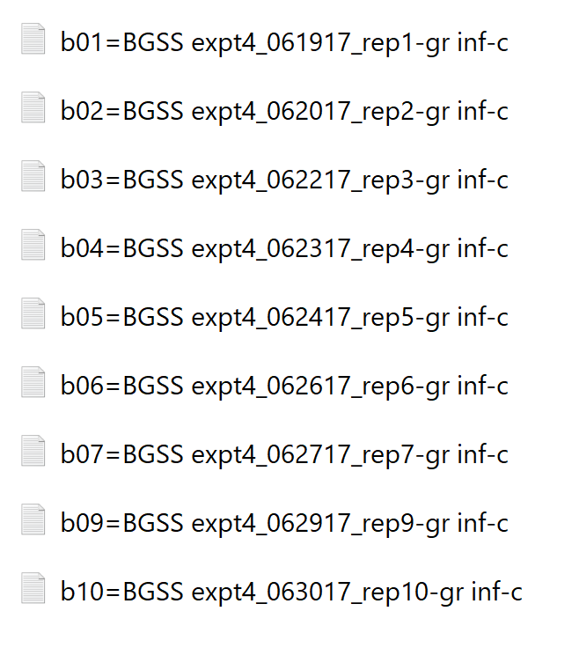Grape Infected treatment Wild Infected treatment

